***PIZZA SALES SQL QUERIES***

***KPI***

***1.TOTAL REVENUE:***

SELECT SUM(total_price) FROM pizzacsv;

SELECT SUM(total_price) AS Total_Revenue FROM pizzacsv;

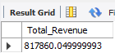

***2. AVERAGE ORDER VALUE:***

***SELECT SUM(total_price) / COUNT(DISTINCT order_id) as Avg_Order_Value from pizzacsv;***



***3.TOTAL PIZZA SOLD:***

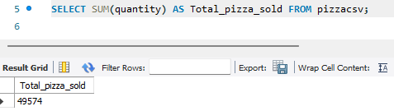

***4.TOTAL ORDERS:***

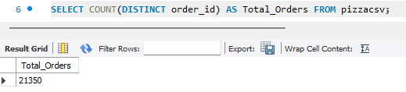

***5.AVERAGE PIZZA PER ORDER:***

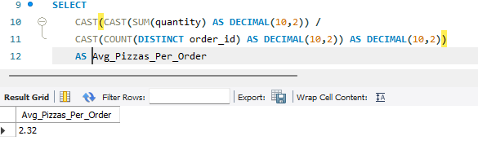

***6. Daily Trend for Total Orders:***

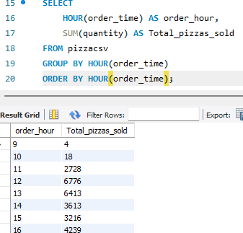

***7. Monthly Trend for Orders:***

**SELECT**

**MONTHNAME(STR_TO_DATE(order_date, '%d-%m-%Y')) AS Month_Name,**

**COUNT(DISTINCT order_id) AS Total_Orders**

**FROM**

**pizzacsv**

**GROUP BY**

**MONTH(STR_TO_DATE(order_date, '%d-%m-%Y')),**

**MONTHNAME(STR_TO_DATE(order_date, '%d-%m-%Y'))**

**ORDER BY**

**MONTH(STR_TO_DATE(order_date, '%d-%m-%Y'));**

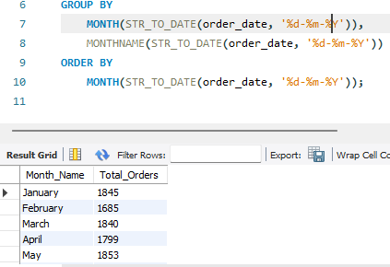

***Q8.% of Sales by Pizza Category***

**SELECT**

**pizza_category,**

**CAST(SUM(total_price) AS DECIMAL(10,2)) AS Total_Revenue,**

**CAST(**

**SUM(total_price) * 100 /**

**(SELECT SUM(total_price) FROM pizzacsv)**

**AS DECIMAL(10,2)**

**) AS PCT**

**FROM**

**pizzacsv**

**GROUP BY**

**pizza_category;**

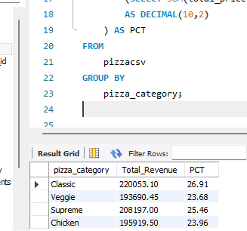

***Q9.% of Sales by Pizza Size***

**SELECT**

**pizza_size,**

**CAST(SUM(total_price) AS DECIMAL(10,2)) AS Total_Revenue,**

**CAST(**

**SUM(total_price) * 100 /**

**(SELECT SUM(total_price) FROM pizzacsv)**

**AS DECIMAL(10,2)**

**) AS PCT**

**FROM**

**pizzacsv**

**GROUP BY**

**pizza_size**

**ORDER BY**

**pizza_size;**

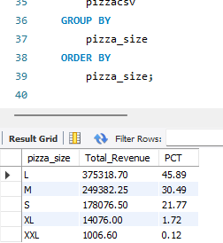

***Q10. Total Pizzas Sold by Pizza Category***

**SELECT**

**pizza_category,**

**SUM(quantity) AS Total_Quantity_Sold**

**FROM**

**pizzacsv**

**WHERE**

**MONTH(STR_TO_DATE(order_date, '%d-%m-%Y')) = 2**

**GROUP BY**

**pizza_category**

**ORDER BY**

**Total_Quantity_Sold DESC;**

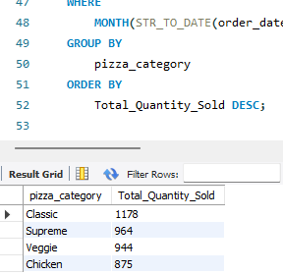

***Q11. Top 5 Pizzas by Revenue***

**SELECT**

**pizza_name,**

**SUM(total_price) AS Total_Revenue**

**FROM**

**pizzacsv**

**GROUP BY**

**pizza_name**

**ORDER BY**

**Total_Revenue DESC**

**LIMIT 5;**

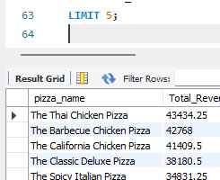

***Q12. Bottom 5 Pizzas by Revenue***

**SELECT**

**pizza_name,**

**SUM(total_price) AS Total_Revenue**

**FROM**

**pizzacsv**

**GROUP BY**

**pizza_name**

**ORDER BY**

**Total_Revenue ASC**

**LIMIT 5;**

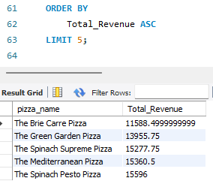

***Q13. Top 5 Pizzas by Total Orders***

**SELECT**

**pizza_name,**

**COUNT(DISTINCT order_id) AS Total_Orders**

**FROM**

**pizzacsv**

**GROUP BY**

**pizza_name**

**ORDER BY**

**Total_Orders DESC**

**LIMIT 5;**

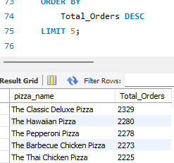

***Q14: Bottom 5 Pizzas by Total Orders***

**SELECT**

**pizza_name,**

**COUNT(DISTINCT order_id) AS Total_Orders**

**FROM**

**pizzacsv**

**GROUP BY**

**pizza_name**

**ORDER BY**

**Total_Orders ASC**

**LIMIT 5;**

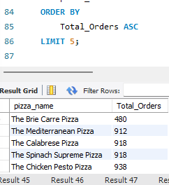

***Q15: Top 5 Pizzas by Quantity Sold***

**SELECT**

**pizza_name,**

**SUM(quantity) AS Total_Pizza_Sold**

**FROM**

**pizzacsv**

**GROUP BY**

**pizza_name**

**ORDER BY**

**Total_Pizza_Sold DESC**

**LIMIT 5;**

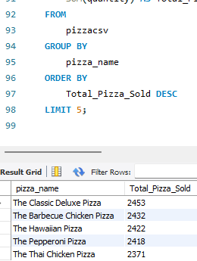

***Q16: Bottom 5 Pizzas by Quantity Sold***

**SELECT**

**pizza_name,**

**SUM(quantity) AS Total_Pizza_Sold**

**FROM**

**pizzacsv**

**GROUP BY**

**pizza_name**

**ORDER BY**

**Total_Pizza_Sold ASC**

**LIMIT 5;**

